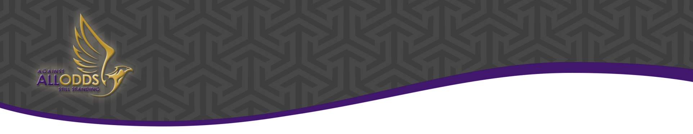
AOS MEMBERSHIP FORM
  - Against All Odds Still Standing (AOS) UK | Website: www.aosuk.org | Email: accounts@aosuk.org
When you choose to join AOS Charity as either a life-long member or a full member, you agree with AOS’ rules and regulation as set out in the constitution. Upon approval by the Board your request will allow you to join AOS UK Charity, therefore, accepting the objectives for AOS’ established purpose. Corporate members are welcome. Your membership donated fees will go towards AOS’ general funds. By providing your personal data to the Charity you acknowledge that your personal data will be processed in accordance with AOS Charity’s Privacy Policy See here.

Members benefits: Includes access to resources, information, or support. A sense of contribution to society and involvement; and a chance to learn and develop as individuals. Can be nominated as Trustee. Tangible benefits, for example, are reduced admission fees for in-house and external events/trips, etc. Opportunity to go on life changing missions and/or be involve in UK or international projects. Gain valuable experience as a Volunteer.
Apply as a Full Member
- Voting member
- Subscription – minimum £15 per month or one-off minimum contribution of £175 pa; renewable annually for three years.
- Attend general meetings.

Apply for Life Membership
- Voting member
- Subscription – minimum £55 over ten months or one-off minimum donation of £510.
- Attend meetings & form sub-committees.
- Member’s Liability one off £10 only if Charity become insolvent.

Applicant’s Contact & Details
Title & Full Name:
Full Address:
Post Code:
Mobile Number: |  | Email Address:
Class of Membership: | Full Member ☐ or Life Member ☐ (Select box that applies)
Who Recommended you?
How did you find out about us?
Subscription Member’s Fee:  (Please feel free to donate more than the minimum amount)  Monthly Amount: £  Bank Start Date: Click or tap to enter a date.  One-Off Annual Amount: £  Bank Transfer Date: Click or tap to enter a date. | Please pay via Bank Transfer or set-up a Standing Order to: -  Name of Account: Against All Odds Still Standing  AOS Bank Name: Barclays Bank Plc  Sort Code 2 0 2 5 4 3  Account Number 9 3 7 3 0 9 7 2  Ref: Your full Name  Please treat my giving as a gift aid donation by selecting the box. If you are a taxpayer, we can reclaim tax on your giving. ☐  1st Signature: 2nd Signature:  Today’s Date: Click or tap to enter a date.
Please upload to www.aosuk.org/aos-membership or email the completed form to: accounts@aosuk.org. You may also post to 18 Tudor Close, Dartford, Kent, DA1 3HU. Telephone enquiry: +44 (0)1322 640527.
For Office Use Only
Amount Received: | Click or tap here to enter text. | Receipt Number: | Click or tap here to enter text.
Membership Class: | ☐FM | ☐LM | Membership No. | Click or tap here to enter text.
Approved by (Signature): |  | Date: | Click or tap to enter a date.

AOS MEMBERSHIP INFORMATION

Against All Odds Still Standing (AOS) UK

Ending violence and abuse against women & children

Access to Specialist Support Services – Working for Secure and Robust Communities

Support for survivors and vulnerable people to domestic violence and abuse or gender-based inequalities
We rebuild lives, restore hope and dignity.
AOS purpose is set out in its objectives as follows:
To relieve the needs of women and children, but not exclusively ethnic minority women and children, who have experienced domestic violence or abuse by:
- The provision of appropriate specialist support and services.
- Providing training to people working with domestic violence and abused victims/survivors or those who are potentially vulnerable to gender-based violence and abuse; and
- Raising public awareness of domestic violence and abuse.

What is on offer? Services are Centred on Survivors.
Confidential advice and support for victims and survivors of violence against women and girls whether in the UK or Internationally. Assessed Specialist Support services provide group and one to one support to all women and girls who have experienced any form of gender-based violence or abuse and gender inequalities.

Your part:
By partnering with AOS, you will help our operations provide support to victims who through no fault of their own have experienced either domestic abuse or gender-based violence.

As a member, you will also help us to provide:
- Specialist support primarily for BAME victims, some are refugees, immigrants, and asylum seekers.
- Support against early and forced marriage.
- Support against Female Genital Mutilation (FGM).
- Support against laddish girl gang culture to exit.
- Refuge (Safe Haven).

Many are orphans, widowed, weak and vulnerable. Your support will also include work on:

- Women and children’s health projects
- Education projects
- Social development and programmes
- Empowerment and income-generating Projects
- Building and infrastructure projects
Our VALUES – Serve | Hope | Trust.
We look to Serve our Beneficiaries and communities - to give back, rather than to take.
We want to restore Hope and dignity for all peoples' we come across to help.
We seek to comply and build Trust with all our Members and Stakeholders.

Our part:
AOS sessions develop coping strategy that build emotional wellbeing and mental health to rebuild lives.

The workshop will help women and girls to recover, e.g., over-come isolation, rejection, and the stigma.

Attendees build confidence to lead independent lives, improve life chances and improve their quality of life.

Person’s centred model approach.
Processes are based upon a proven successful method of AOS’ Unique Programme, which utilises Fikelephi’s personal touch process that makes this service uniquely different.

This model approach uses a combination of strong cultural empathy, active listening, and inspirational techniques to achieve positive impact and results.

Rebuilding lives, Restoring hope and Regaining dignity.
Serving our communities

